here I put basic information based on the previous webpages of ecoflor:

<https://www.ecoflor2025.es/>

<https://pollinet.wixsite.com/ecoflor-2024>

<https://ecoflor2023.weebly.com/>

consider that I do not include graphical information (e.g. pictures), links to important material already not developed (e.g. programme, abstract book, workshop, social media) or sponsor logos

**HOME**

# Welcome to the 23rd Annual Meeting of the Spanish Group for Floral Ecology and Evolution (ECOFLOR)

We are pleased to announce the celebration of the 23rd edition of the Annual Meeting of the Floral Ecology and Evolution working group - EcoFlor -, which will take place on 11th – 14th February 2026 in Tortosa.

EcoFlor is a working group from the Spanish Association of Terrestrial Ecology (AEET; https://www.aeet.org/es/gruposdetrabajo/ecoflor.html) and organises an annual meeting in the form of a congress to talk about science. In 2026, the meeting will be held at the Centre Cívic Ferreries, in the city centre of the medieval city of Tortosa, located on the riverbank of the Ebro river.

EcoFlor annual meeting brings together scientists interested in floral ecology and evolution, with the aim of promoting discussion, networking and creativity in science and involving students from all career stages in the process in an open and friendly environment. The participants are invited to present their ongoing projects' results and engage in critical scientific discussion and networking. In recent years, EcoFlor has extended its frontiers and has reached an international dimension, receiving contributions from researchers from all over the world.

Following the traditional format, the meeting will consist of two days of presentations (Thursday and Friday), with plenary talks and oral and poster contributions that will be structured thematically according to the abstracts received.

In addition, there will be workshops on Wednesday and a field trip on Saturday to the Natural Parks of Ports (mountain range, area affected by a recent wildfire) and Delta (aquatic ecosystems, ecosystem restoration area).

The congress dinner will be on Thursday night.

Contributions should be in English to promote discussion and interaction with the international audience.

**ORGANIZATION**

The 23RD edition of EcoFlor meeting is organised by **the Wildlife Pollinators Group**, a research group of the **Wildlife Ecology and Health** **Lab** (https://weh.cat/), based in the Veterinary Faculty of the Autonomous University of Barcelona (UAB).

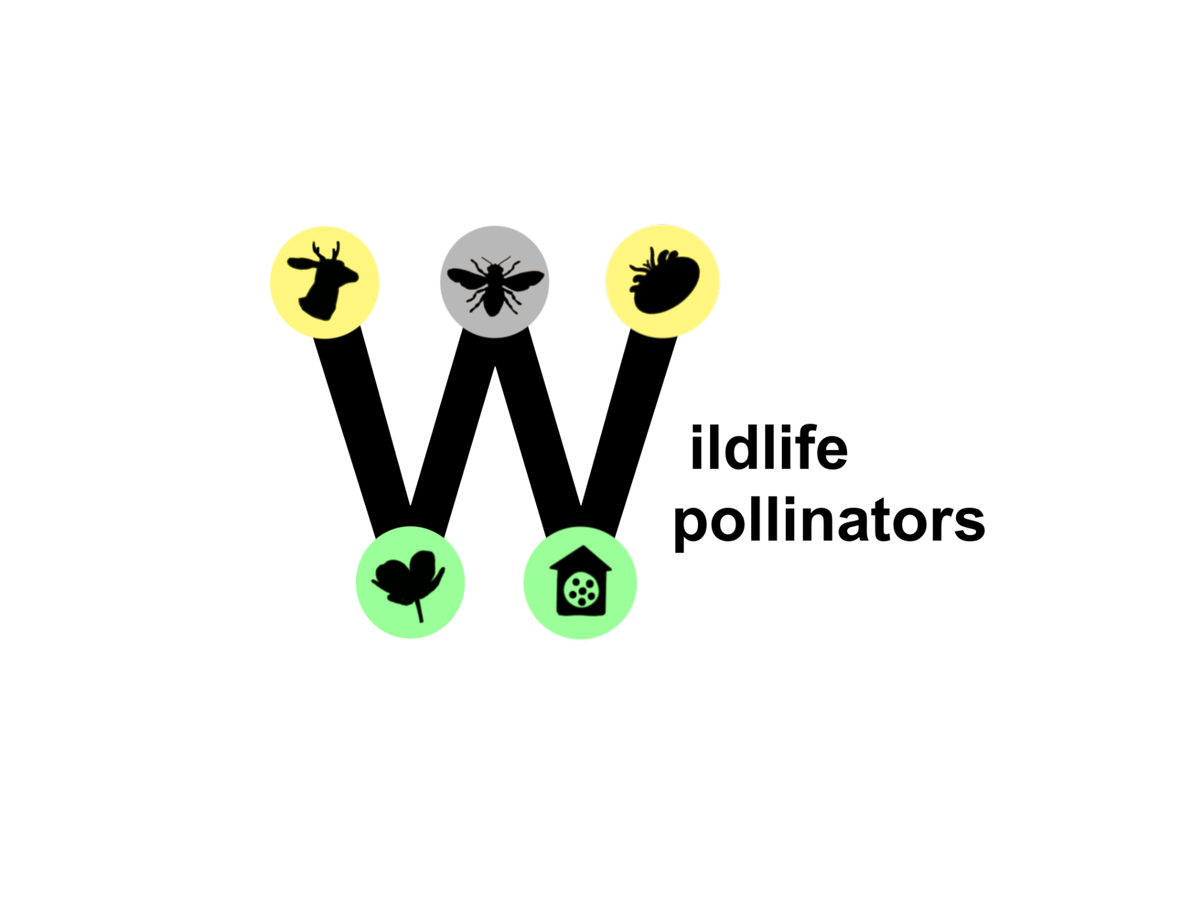

Additional researchers from different institutions (IRTA, CTFC, IVIA, CREAF) are actively involved in the organisation.

In the Wildlife Pollinators Group we study the relationship between large herbivores (domestic and wild) and plant-pollinator communities and interactions,as well as in pollination function. We are also interested in understanding how other processes operating at large scales (such as wildfires) influence the assemblage of these communities. On the opposite (microscopic scale) side, we are interested in disentangling the mysteries behind solitary bee health. We conduct basic faunistic studies as well as research on bee diversity patterns in multiple types of habitats (including urban ecosystems, riparian ecosystems, and grasslands).

**Organizing committee**: Carlos Hernández-Castellano, Néstor Pérez, Jordi Margalef-Marrassé, Alice Casiraghi, Jakub Štenc, Marina Aguilar, Júlia Batlle-Benaiges, Júlia Coromina, Nil Guerrero

above idea from ecoflor 2024

nice if we do also something similar to ecoflor 2023 (profiles)

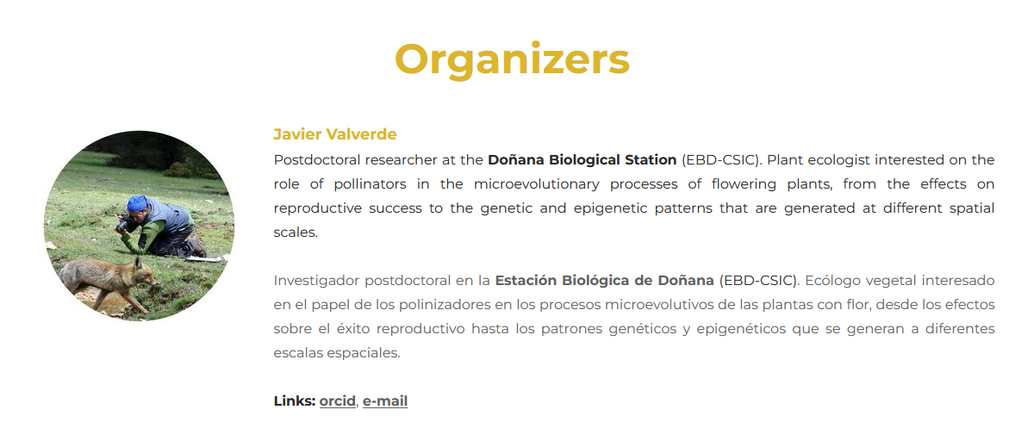

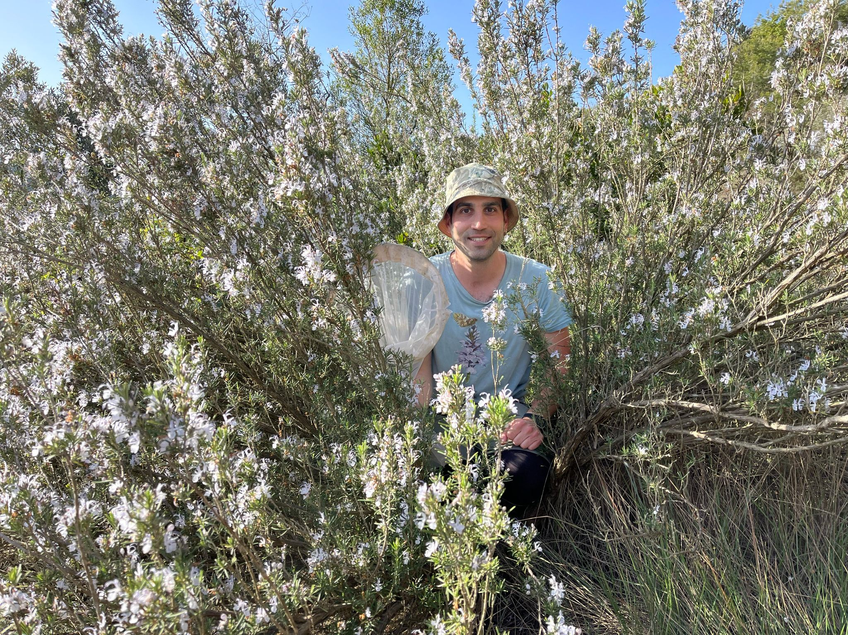

**Carlos Hernández-Castellano.** Postdoctoral researcher at the Autonomous University of Barcelona (Department of Medicine, Veterinary Faculty), currently based at the Czech University of Life Sciences (Prague, Czech Republic). He is an ecologist with expertise in plant-pollinator interactions and with interest in multiple topics of bee ecology, ranging from the consequences of large-scale disturbances (herbivory and wildfires) to the study of bee health. He is also interested in the diversity patterns of bees in multiple ecosystem types, including urban environments.

<https://scholar.google.es/citations?user=N20Q75MAAAAJ&hl=es>

[carlos.hernandezcastellano@gmail.com](mailto:carlos.hernandezcastellano@gmail.com)

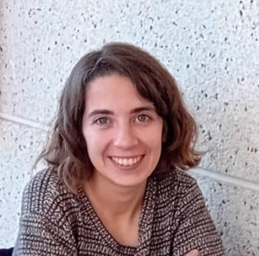

**Alice Casiraghi.** PhD candidate at the Valencian Institute of Agricultural Research (IVIA), specializing in community ecology. Her doctoral research focuses on arthropod trophic webs (including pollinator-plant relationships) associated with different cover crop treatments in citrus agroecosystems. In addition to her thesis work, she has gained experience as a specialist in aphid–parasitoid interactions in wheat fields and is actively involved in aphid taxonomy studies during her free time.  
<https://scholar.google.com/citations?user=J6BL1f0AAAAJ&hl=es>  
[theaphidologist@gmail.com](mailto:theaphidologist@gmail.com)

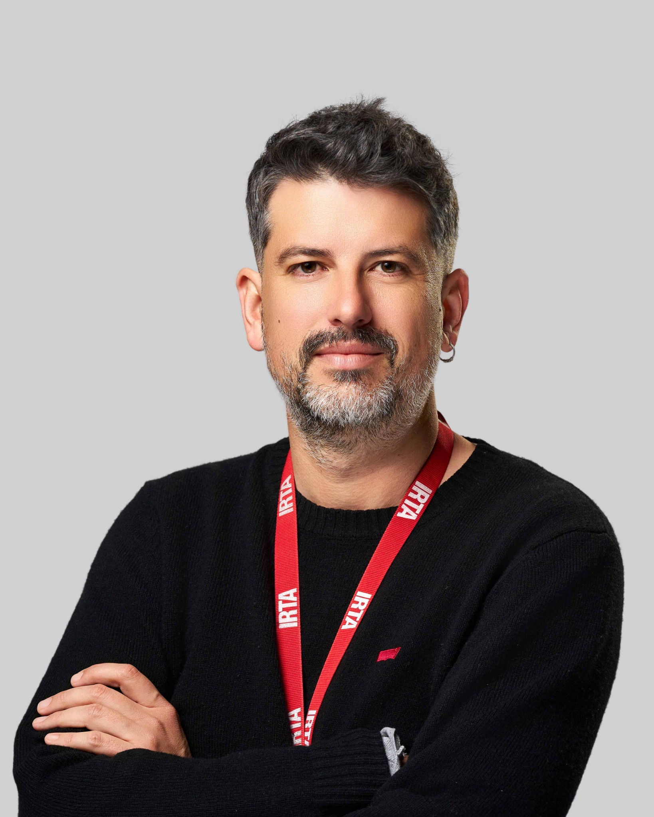

**Néstor Pérez-Méndez.** Ramon y Cajal Researcher at the Institut de Recerca i Tecnologia Agroalimentàries (IRTA). I am an ecologist broadly interested in (i) assessing how global change drivers affect the functioning of natural and agricultural systems, and (ii) identifying and evaluating agricultural management strategies that reconcile crop production with biodiversity conservation.

<https://scholar.google.es/citations?user=9cVCRHcAAAAJ&hl=es>

[nestor.perez@irta.cat](mailto:nestor.perez@irta.cat)

Instagram account for wildlife photography: @raw_natura

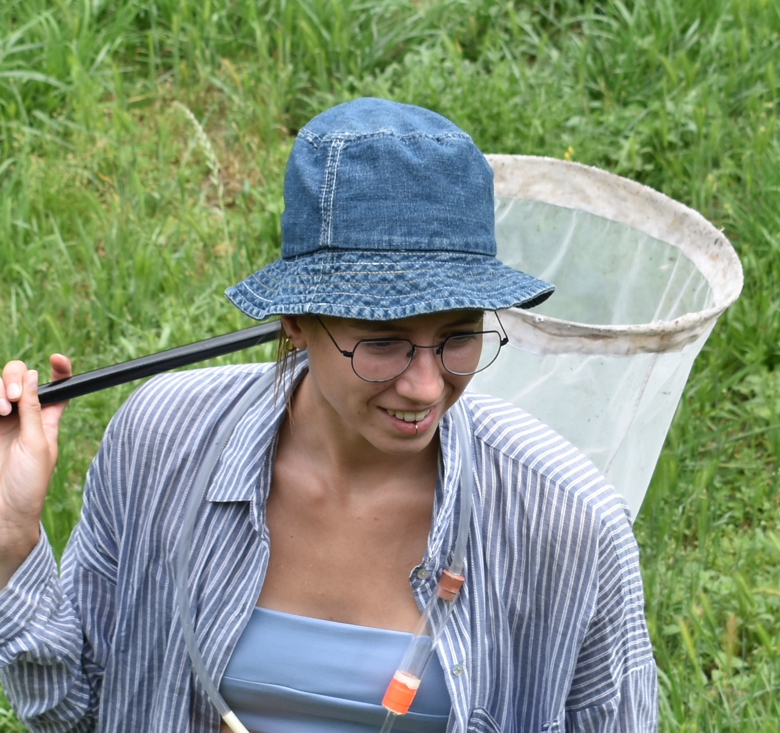

**Júlia Batlle-Benaiges.** M.Sc. Wildlife and Biodiversity student at the University of Freiburg. She is interested in bee ecology and in the resilience of plant-pollinator networks to disturbances such as herbivory. For her Bachelor's thesis, she investigated the effects of pasture size and grazing intensity on bee diversity patterns. She has also gained experience using nesting traps to study cavity-nesting bees and wasps.

<https://scholar.google.com/citations?user=cr9FBjkAAAAJ&hl=ca>

[ju.ba.benaiges@gmail.com](mailto:ju.ba.benaiges@gmail.com)

**PROGRAMME**

February 11th

Workshops

Workshops will occur in the venue, Centre Cívic Ferreries. To participate in the workshops, **you must be registered**. Further information will be sent to all participants.

Workshop 1: Nesting traps for cavity-nesting bees and wasps in ecological studies: biology, ecology, materials and methods

Nesting traps simulate nesting resources for a wide diversity of bees and wasps. They are useful to standardize sampling and sample a lot of sites simultaneously. However, nesting traps can be designed in multiple ways, and their use and effectiveness is dependent on the scientific questions addressed as well as in the knowledge of the natural history of bees and wasps. In this workshop we will provide basic knowledge on the biology and ecology of cavity-nesting bees and wasps, and we will provide specific recommendations on which materials to use and how to install them to assure replicability and effectiveness of sampling.

Instructors: Júlia Batlle-Benaiges, Júlia Coromina, Carlos Hernández-Castellano

Schedule: Wednesday morning, 10-13h.

Workshop 2: Emerging priorities in plant-pollinator systems research in Mediterranean ecosystems

Plant-pollinator systems are essential to sustain biodiversity and function in ecosystems. Indeed, they are one of the main research topics in the ECOFLOR community, and include, among others, the study of the evolution of breeding systems, pollination ecology, spatio-temporal variation in pollinator communities, and ecological networks. In a context of global change, the scientific community is adapting continuously to research and management challenges imposed by the need to reverse negative impacts and restore the integrity of ecosystems. In this workshop, we want to organize a Horizon Scan to identify research and management priorities in plant-pollinator systems research in Mediterranean ecosystems for the next decade. This will be conducted within the ECOFLOR community and will yield a multi-authored, collaborative paper, published in a scientific journal related to the research topic.

Instructors: Carlos Hernández-Castellano, Ignasi Bartomeus

February 12th and 13th

Meeting

The meeting will consist of two days of presentations, with **plenary talks** and **oral and poster contributions** that will be structured thematically according to the abstracts received.

All the **oral and poster communications instructions** can be found in the **Registration** tab in the top menu. For additional questions, please contact the organisation through the email ecoflor2026@gmail.com.

On thursday 12th there will be the congress dinner at XXX. Cost XXX

Plenary Speaker

Prof. Juli Pausas, “Fire and plant reproduction”

**Bioscketch**: Juli G. Pausas is a CSIC Research Professor at *Centro de Investigación sobre Desertificación* (CIDE, Valencia, Spain) of the Spanish National Research Council (CSIC). His research focuses on [ecology and evolution of mediterranean and fire-prone ecosystems](https://www.uv.es/jgpausas/fire-ecology-evolution.html), and specifically on understanding the role of fire in shaping populations, species (i.e., fire traits), communities (i.e., assembly processes), landscapes, and biomes. While his primary experience is in Mediterranean ecosystems, he possesses a broad, global perspective on ecology. He has participated in several successful international research projects and has experience in both field and modelling studies. He has written more than 200 [scientific papers](https://www.uv.es/jgpausas/papers.htm), co-edited an international book on the [ecology of Cork oak woodlands (Island Press)](https://www.uv.es/jgpausas/corkoak.htm), co-authored a book on [Fire ecology in Mediterranean ecosystems (Cambridge Press)](https://www.uv.es/jgpausas/fire-book.htm), and book in Spanish on [fire ecology](https://www.uv.es/jgpausas/incendios.html).

Plenary Speaker

Cristina Botías

Cristina Botías is a *Ramón y Cajal* Research Fellow at the University of Alcalá. She holds a PhD in Veterinary Science from the Complutense University of Madrid, completed at the Apicultural and Agri-environmental Research Center (CIAPA–IRIAF), where she studied the effects of honeybee pathogens at both individual and colony levels. Her doctoral work, awarded the PhD Extraordinary Prize, provided key insights into how emerging diseases affect bee health and colony performance. Following her PhD, Cristina conducted postdoctoral research at the University of Sussex (UK), investigating pesticide exposure and its interactions with other stressors, such as pathogens. Her findings highlighted that bees are exposed to higher and more prolonged pesticide levels than previously thought. She later held a *Juan de la Cierva* Fellowship at the Estación Biológica de Doñana–CSIC, focusing on disease pressures in wild bees, and subsequently returned to CIAPA–IRIAF with an INIA-DOC fellowship to continue her research on wild pollinator health. Since 2022, she has been based at the University of Alcalá, where her research focuses on the pathogenesis and epidemiology of pathogens affecting bumblebees and other pollinators. She also teaches undergraduate courses in Zoology and Sanitary Entomology within the degrees of Environmental Sciences, Biology, and Sanitary Biology. Cristina has published over 50 scientific articles and led several research projects funded by regional, national and international bodies. She is also active in outreach efforts, promoting awareness of pollinators' ecological importance and the threats they face.

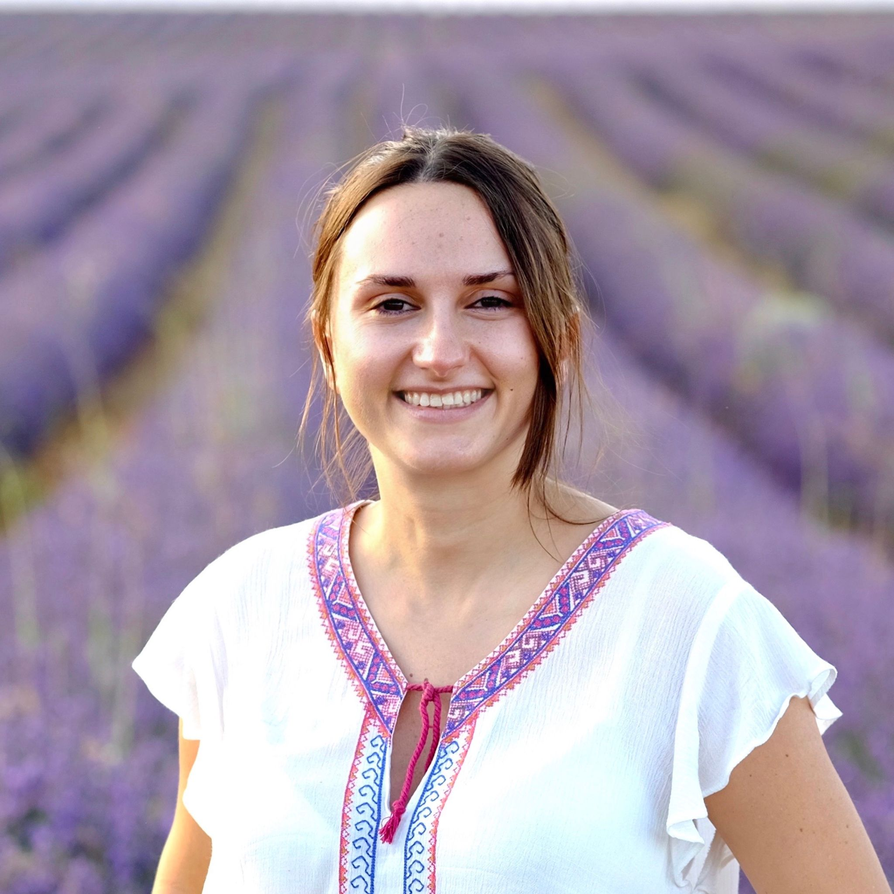

## **Saturday 14th**

### **Ports Natural Park**

The Ports Natural Park is a sub-Mediterranean ecosystem predominantly mountainous and dominated by forests. It is located in the southernmost part of Catalonia (NE Spain), being part of the Iberian System mountain range and formed of calcareous mesozoic materials.

In July 2025, a wildfire originated in Paüls (a municipality close to the Ebro river) affected more than 3000 hectares of mainly *Pinus halepensis* forest.

In the first part of the field trip, we will visit the area affected by the wildfire. In the first part of the visit, we will learn about 1) the ecosystems and conservation strategies present in the Ports Natural Park; 2) how the wildfire started, developed, and its consequences in the affected area; and 3) the current status of forests and fire regimes in this region. We will also discuss several topics of ecological relevance for plant-pollinator systems in areas affected by wildfires, including ongoing projects and studies.

**Delta Natural Park**

The Ebro Delta Natural Park is one of the most important and biodiverse wetlands in the Western Mediterranean, covering around 320 km2 of rice fields, lagoons, salt marshes and sand dune systems. The Ebro Delta hosts a highly diverse community of waterbirds, including important populations of some iconic species such as the Audouin gull. During the second part of the visit, we will have lunch in the “Casa de Fusta” restaurant, where we will taste several local dishes (cost ~30€). Then we will visit the “Finca Bombita”, a former 500-ha rice farm that is being rewilded to promote biodiversity and face climate change impacts on the territory. Together with the environmental managers, we will have the opportunity to discuss: (i) the effects of climate change on sensitive environments such as the Ebro Delta, (ii) potential strategies and NbS to reduce these impacts, and (iii) the socio-environmental challenges involved in carrying out this type of restoration projects.

**Departure will be at 8 am and arrival at ~6pm, with the possibility to come back to Barcelona.**

**REGISTRATION**

**Registration** and **abstract submission** are now **open until November 30h**.

Submit your oral or poster contribution in the form.

-Registration fees: Attendance at the meeting is free of charge, but registration is mandatory because of meeting logistics. Please fill in the form if you intend to attend the meeting.

-Contributions: When registering, you can also submit your proposal for an oral or poster communication. Best oral and best poster will be awarded.

Senior researchers can also and are also welcome to propose opening talks. These talks will last slightly more than oral presentations and will consist of small lectures on research lines, breakthrough ideas or emerging topics of scientific interest, rather than results of specific studies.

We also welcome proposals on workshops to be conducted on Wednesday 11th (the day of arrival). We especially appreciate workshops to develop abilities for early-career researchers, such as fieldwork methods, sample processing and laboratory protocols, or data analyses and writing. Discussion on emerging topics of interests and networking are also needed!

There is a **questionnaire** at the end of the form to find out if you would be interested in **participating in the parallel activities**. As we know the potential attendance we will provide more information to participants.

-Important note: The capacity of the meeting is limited to 100 participants. For this reason, acceptance to attend the conference will be based on the order of registration, whether attendees submit a contribution and their scientific scope. We encourage young researchers to submit their contributions, as the scientific commission of the meeting will give them priority in case of acceptance.

-Instructions for communications

Abstract preparation: Please submit your abstract during registration, following the instructions provided in the forms.

- Abstracts should in **english** and not exceed **200 words.**

- Indicate five keywords for organising the conference sessions.

- Only one contribution per main author.

- We'd appreciate the main author to be the one submitting the abstract.

Oral communications: Oral presentations will have a duration of 12 minutes and slides should be in English. The accepted presentations must be sent by email to ecoflor2026@gmail.com until February 2nd. The organisation committee will guarantee that the file is used only for projection during the meeting and will be deleted immediately after the end of the meeting.

Poster presentations: ​Posters will be exposed during the meeting, in a room besides the main hall. Poster session will coincide with coffe breaks: 30min during the morning and 1h in the afternoon. The coffe (beer) break in the afternoon will be handled at the end of the oral presentations, and it is especially intended to foster discussion with those presenting posters, as well to foster participation and networking with the parallel activities ().

**VENUE**

Tortosa

**Welcome to TORTOSA!** The 23rd edition of EcoFlor takes place at the Centre Cívic Ferreries. This historical building (ancient markent) is located in the city center of Tortosa.

Oral Presentations (including plenary talks) will take place in the Main Hall.

Posters will be exposed in the room next to the Main Hall.

Workshops will be conducted in…

There are up to three spaces (two small meeting rooms, one big hall with panoramic view to the Main Hall) upstairs. Consider this if you need to work some time or to meet with colleagues. You could book the room some period of time by 1) mailing to the organization, or 2) writing it in the room schedule (blank paper in the door).

-How to get there

*For those coming from abroad and landing at Barcelona airport, it is supereasy to reach Tortosa, since there is a direct bus (Hife company) connection with departures every hour. Traject is ~2h. Remember to buy the ticket with antelation.

<https://www.hife.es/en>

*If you are already in Barcelona, you may get the train R16 from Sants Train Station. Departures are approximately every 1-2 hours and traject is also ~2h.

<https://www.renfe.com/es/en>

Consider that you can also get the bus (Hife) from several bus stops in Barcelona, with direct connections to Tortosa.

*For those coming in car (e.g. Spain), just get the exit number 40 in the AP-/ railway.

If you find any problem, contact the ECOFLOR organization.

-Where to stay

*Hotel Corona is close to the venue and kindly offer the attendees a 10% discount after reservation in their website indicating the code ECOFLOR26

<https://www.sb-hotels.com/en/hotels/terres-ebre/corona-tortosa/>

*Parador de Tortosa is an ancient building within the medieval castle. It is a majestic place, probably a bit far away from the venue (so assure you will be able to move properly), but if you want to feel the real Tortosa experience, go there. They kindly offer to us a 15% discount if booking is made early.

<https://paradores.es/en/parador-de-tortosa?gad_campaignid=18590350485&gad_source=1&gclid=Cj0KCQjw18bEBhCBARIsAKuAFEYlHVzsbVzRjAfbLQMYsuRE9CfrUheCecxlB0gDK_WGobp553gn1iMaAr--EALw_wcB&gclsrc=aw.ds>

*More hotels, hostels, flats, and so on

can be found at

<https://www.tortosaturisme.cat/en/hotels-more/>

Consider that Tortosa is a small city, so do not wait unti the last minute to book accommodation! If you find any problem, contact the ECOFLOR organization.

-Where to have lunch

*Close to the venue there are a lot of bars (e.g. Bar Ñoño) and restaurants (never a limiting factor in Spain!)

However, for those who want (no need for reservation) the Restaurant lo Llaüt (traditional southern catalan cuisine) will offer to us a genuine and affordable menu (based on traditional and authentic paella) on thursday and friday. Very (very) recommendable.

*Another fantastic and genuine option is to have lunch in Mercat de Tortosa, a genuine Mediterranean market where fresh fruit, vegetables, fish and meat, mingle with quick and delicious cooking in bar stands (Market cuisine).

If you go there, you simply HAVE TO go to Bar Ester. They are simply the best. Try the traditional “abadejo” (cod), eels, cap-i-pota, artichoke omelette, and so on (everything local).

-Where to have dinner and beers

Once the congress sessions end in the afternoon (~19h) we will cross the bridge over the Ebro river, admire the Cathedral in front of us, and face two streets where plenty of bars and restaurants will help us continue networking:

*Avinguda de la Generalitat

*Carrer de Sant Blai

Anything there and between these streets will be fine.

Remember to join the Whatsapp group ECOFLOR Dark-Side for further information (floral ecology and evolution continue at night!).

-WHAT TO VISIT

-if you are planning to come to Tortosa earlier or to stay a couple of days more after the congress, you may find useful this webpage:

<https://www.tortosaturisme.cat/en/>

Here you can find several options to enjoy the city, but also the surroundings. Tortosa is an small, ancient city in southern Catalonia, crossed by a river, and between two natural areas (mountains and sea). There is plenty of history, culture, gastronomy (and very good white wines), and an extraordinary natural environment. We will try our best to make you feel everything of these.

CONTACT

If you need to contact us, please do it through the following email address: [ecoflor2026@gmail.com](mailto:ecoflor2026@gmail.com)

You can also use social media XXX to reach us, get updated with all the news and more!